Rusty Crayfish Worksheet
Name: ____________________________________________________________ Date: ______________
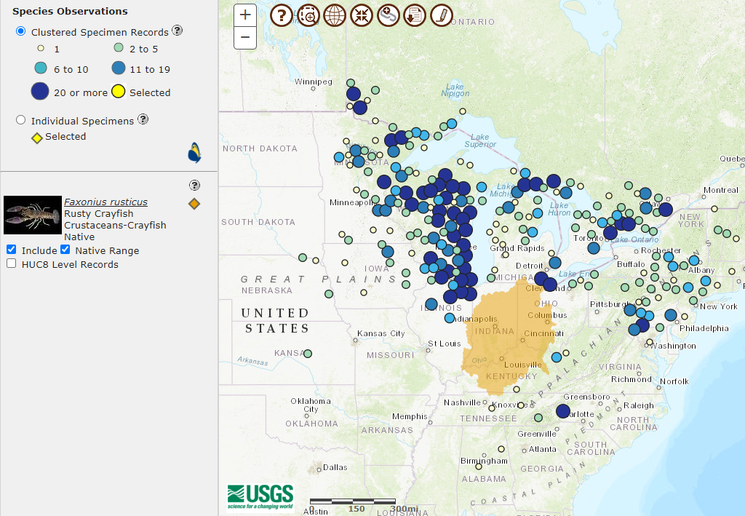
Rusty crayfish (Orconectes rusticus) clustered specimen records and native/HUC8Level Range. Source: USGS, 19 January, 2023. https://nas.er.usgs.gov/viewer/omap.aspx
A rusty crayfish’s “native range” is marked in gold. Rusty crayfish found outside that range are invasive. Dots on the map show how many rusty crayfish were found in each location (bigger dot = more rusty crayfish!).
Mark an arrow on the map the direction you think Rusty crayfish traveled from their native range.

How do you think rusty crayfish moved through different lakes?

Describe two characteristics you can use to identify rusty crayfish.

What can you do to prevent AIS from establishing in lakes around here? Name two things.

